

**PLAGIARISM DECLARATION FORM (T-DF)**

|  |
| --- |
| **Instructions**  **Please complete and attach this Plagiarism Declaration Form to each Assignment that you submit into the Online Assignment Submission (OAS) system for marking.** |
| I declare that the attached work is entirely my own (or when submitted to meet the requirements of an approved group assignment is the work of the group), except where materials cited, quoted or paraphrased are acknowledged in the text. I also declare that this work / assignment has not been submitted for assessment in any other course or university without due acknowledgement.  I understand that plagiarism, collusion, and copying are grave and serious offences.  I understand that disciplinary action (which may include deduction of marks in the Assignment) will be taken against me if I am found to be an offender of Assignment plagiarism.  **Full name and IC No: WONG KONG WENG 810906-10-5533 Date: 14 JULY 2024** |

|  |  |
| --- | --- |
| **Assignment Declaration Form** | |
| Semester/Year | **MARCH 2024** |
| Student’s Name | **WONG KONG WENG** |
| Student’s ID No: | **031080253** |
| Course Code | **TSN309/10** |
| Course Title | **CSN Project** |
| Class Code | **TSN309/10 - CSN2-SEP23** |
| Assignment No: | **1** |
| No. of pages of this Assignment *(including this page)* | **44** |
| Project Supervisor | **Mr HO HSIAO FOONG** |
| Course Lead | **Pn Azrina** |

***T-DF*** *Assignment Declaration Form (1/2020 version #003)*

**PROJECT TITLE**

***IT INTEGRATION STRATEGIES FOR SME RETAIL STARTUPS :***

***A CASE STUDY OF URBAN VIBE***

**STUDENT NAME**

**WONG KONG WENG**

**STUDENT NO.**

**031080253**

**Final Reprt**



**SCHOOL OF SCIENCE AND TECHNOLOGY**

**MAY 2024**

# COPYRIGHT DECLARATION

Wawasan Open University

Session: **May 2023**

I, **WONG KONG WENG** declare that this report shall be the property of Wawasan Open University and I allow copies of it to be made for academic purposes.

________________________________________________________

(Signature)

Date: ____14TH JULY 2024_________________

# ORIGINAL DECLARATION

I declare that this report titled “***IT INTEGRATION STRATEGIES FOR SME RETAIL STARTUPS : A CASE STUDY OF URBAN VIBE***” is my own work except where cited in the references. The report has not been accepted, and is not being submitted in candidature, for any degree or other award elsewhere.

__________________________________________________________

(Signature)

WONG KONG WENG

___________________________________________________________

(Name in full as your NRIC)

Date: ________14 JULY 2023__________________

# ACKNOWLEDGEMENTS

*I extend my heartfelt gratitude to my project supervisor, Mr HO HSIAO FOONG, whose unwavering guidance and support have been instrumental throughout this project. his insightful feedback, patience, and encouragement have propelled me through the various stages of research and writing, enriching the quality of my work.*

*I’m also deeply thankful to my colleague for their invaluable advice and guidance during my progression of work at the Wawasan Open University. it’s enriching my understanding and refining my approach.*

Table of Contents

COPYRIGHT DECLARATION i

ORIGINAL DECLARATION i

ACKNOWLEDGEMENTS ii

INTRODUCTION………………….…………………………………………………….6 - 12

LITERATURE REVIEW ……………………………………………………………….13 - 15

METHODOLOGY...…………………………………………………………………….16 –19

DESIGN & IMPLEMENTATION………………….…………………………………..20 - 31

CONCLUSION …………………………………………………………………………32 - 33

REFERENCE & APPENDIX …………………………………………………………..34 - 44

**Abstract :**

In today's competitive retail environment, the success of Small and Medium-sized Enterprises (SMEs), particularly in the fashion industry, depends on the effective integration of Information Technology (IT) into their operations. However, SMEs often face resource constraints and a rapidly evolving technological landscape. This project aims to develop a tailored IT strategy for SME startups, focusing on IT infrastructure, hardware and software selection, network design, and Point-of-Sale (POS) systems.

The UrbanVibe IT infrastructure project outlines a detailed plan to establish a reliable and scalable IT system for a new fashion company. Based on a hypothetical scenario where I was recruited as an IT manager by UrbanVibe, the task involves creating IT services from the ground up for UrbanVibe headquarters, warehouse, and outlets in different locations.

The scope of the project includes setting up IT infrastructure for UrbanVibe HQ, warehouse, and outlets. Key elements include high-performance workstations, secure and redundant networking, scalable data storage, and robust security measures. The project emphasizes integrating various systems for real-time data sharing, ensuring efficient daily operations across all locations.

By addressing these diverse needs, the project aims to build a secure and efficient IT setup that supports UrbanVibe’s growth and operational requirements. This project provides insights and recommendations to help SME startups like UrbanVibe navigate the complexities of fashion and IT integration, empowering them to thrive in the digital age retail landscape.

**Table of Contents**

**Chapter 1 *Introduction***

1.1 Overview

1.2 Background

1.3 Objective & Scope

**Chapter 2 *Literature Review***

2.1 Background of the Study

2.2 Theoretical Framework

**Chapter 3 *Methodology***

Waterfall approach

**Chapter 4 *Design & Implementation***

4.1 Design of IT architecture

4.2 Construct of System & Network

4.3 Testing

**Chapter 5 *Conclusion and Recommendation***

5.1 Conclusion

5.2 Recommendation and future works

***Reference***

Reference

Appendix

***1. Introduction***

**1.1 Overview**

In today's competitive retail environment, the success of a new SME fashion startup relies on effective Information Technology (IT) integration. Strategic IT deployment can greatly enhance operational efficiency, improve customer experiences, and boost profitability. However, SMEs often face challenges such as limited resources and rapidly evolving technology landscapes.

This project examines how IT intersects with the fashion industry by studying globally renowned fashion retailers. It focuses on IT infrastructure, hardware and software selection, network design, and Point-of-Sale (POS) systems. The goal is to develop a comprehensive IT strategy tailored to SME startups' needs and constraints.

SME startups in the fashion sector face unique IT challenges, including limited budgets, lack of specialized expertise, scalability issues, and the need to quickly adapt to new technologies. Unlike larger companies with established IT departments, SMEs must creatively navigate these hurdles to maximize their IT investments.

To create effective IT strategies for SME startups, this project analyzes global fashion retailers known for their innovative use of technology. By examining case studies and industry reports, the study identifies best practices in IT infrastructure management, hardware and software selection, network design, and POS system implementation. These insights will help develop a practical and customized IT strategy for UrbanVibe, a hypothetical SME startup in the fashion industry.

By aligning global insights with UrbanVibe's specific needs and growth goals, this project aims to give UrbanVibe a competitive edge in the fashion retail market while fostering sustainable growth and customer loyalty.

### 1.2 Background

This project is based on a hypothetical scenario where I have been recruited as an IT manager by a SME Start-up fashion company named "UrbanVibe." I am tasked with setting strategies and implementing all IT related services from scratch to finish for UrbanVibe headquarters (HQ), Warehouse, and Outlet in different geographical regions.

UrbanVibe HQ has four departments: Finance & Admin (FA, 2 users), Human Resources (HR, 2 users), Sales (SA, 2 users), and Information Technology (IT, 2 users). All office users are located on the same floor. However, Warehouse department is located on a different floor within the same premises, with 20 staff members .

UrbanVibe has a outlets located in different regions from the HQ. The outlets require linked to HQ network via secure network for accessing internal file and POS data synchronous and also internet access for basic functionality

**1. Office (HQ)**

**General Requirements:**

* **Workstations:** High-performance computers with necessary software (e.g., Microsoft Office, accounting software for FA, HR management software for HR)
* **Peripherals:** Monitors, All-In-One printers
* **Networking:** Secure and high-speed internet connectivity with redundancy.
* **Data Storage:** Secure and scalable data storage solutions (cloud-based or on-premises) for documents, financial records, HR data, and sales reports.
* **Mobile Devices:** Tablets or mobile phone for staff to stay contactable with office and remain connect to business while on the go.
* **Email and Communication:** Email services (e.g., Microsoft 365), video conferencing tools (e.g. Microsoft Teams), and instant messaging apps (e.g., Whatsapp).

**Specific Needs per Department:**

* **Finance & Admin (FA):**
  + Accounting software (able to integrate with POS solution)
  + Financial reporting tools
  + Anywhere, Anytime Access capability for productivity software
* **Human Resources (HR):**
  + HR management software
  + Recruitment and payroll systems
  + Anywhere, Anytime Access capability for productivity software
* **Sales (SA):**
  + CRM software
  + Sales tracking and reporting tools
  + Anywhere, Anytime Access capability for productivity software
* **Information Technology (IT):**
  + IT management tools.
  + Backup and disaster recovery solutions
  + Rapid deployment

#### 2. Warehouse

**General Requirements:**

* **Workstations:** Durable computers or rugged laptops for inventory management.
* **Peripherals:** Barcode scanners, label printers and network printers
* **Networking:** Reliable and robust network connectivity for inventory systems

**Specific Needs:**

* **Mobile Devices:** Tablets or handheld devices for inventory checks and updates on the go.
* **Warehouse Management System (WMS):** Software to streamline warehouse operations, including receiving, picking, and shipping processes.
* **Integration:** Seamless integration with the HQ systems for real-time data sharing and reporting.

**3. Outlets (located at different location)**

**General Requirements:**

* **POS Systems:** Reliable POS terminals capable of handling sales, returns, inventory checks, and more. POS systems should capable to operate online and offline and able to integrate with Accounting software.
* **Peripherals:** Receipt printers, barcode scanners, and cash drawers.
* **Networking:** Stable internet connectivity with failover options to ensure continuous operations.
* **Data Syncing:** Near real-time data synchronization with the HQ server for daily sales figures and inventory updates.
* **Workstations:** High-performance desktop computers with necessary software (for daily reporting and email & video call conference)

**Specific Needs:**

* **Payment Processing:** Secure payment processing systems that support various payment methods (credit/debit cards, mobile payments, etc.).
* **Mobile Devices:** Tablets or handheld devices for inventory checks and updates on the go.

### 1.3 Objectives and Scope

The project's primary focus on establishing the IT infrastructure for a startup fashion company which included HQ office, warehouse and outlets.

This fresh start offers numerous opportunities but also requires careful consideration of every detail, from basic hardware to complex software solutions. The objective is to equip UrbanVibe with the right tools and technologies needed to thrive in the modern fashion industry by focusing on the following key components:

#### Server Infrastructure

The selection, configuration, and deployment of server hardware and software are crucial for supporting the startup's data storage and processing requirements. The project's scope includes:

* **Server Types and Considerations:** Exploration of various server types, such as on-premises and cloud-based options. The pros and cons of each type will be analyzed, considering factors like scalability, cost, future proof and also the environment impact (less digital carbon foot print)
* **Scalability and Future-Proofing:** Strategies to ensure the server infrastructure can accommodate UrbanVibe's growth will be explored, weighing their pros and cons.
* **Server Security:** Investigation of server security measures, including firewalls, intrusion detection systems, and data encryption, to safeguard sensitive data.
* **Redundancy:** Incorporate redundancy to ensure data availability and system reliability.
* **Performance Optimization:** Employ load balancing and performance monitoring tools to optimize server performance.

#### Network Design

A robust and reliable network is essential for UrbanVibe operations. The network design should consider scalability, security, and redundancy. The project's scope includes:

* **Network Topology:** Consideration of various network topologies, including star, mesh, and hybrid, to assess their suitability for UrbanVibe's offices, warehouse, and outlets.
* **Bandwidth and Speed:** Examination of options for ensuring adequate bandwidth and network speed are selected by exploring all available of ISP in the area and the plan that their offer.
* **Network Security:** Exploration of advanced security measures, including firewalls, VPNs, and intrusion detection systems, to protect sensitive data.
* **Network solution considerations** : Research the supplier/brand’s (e.g Cisco, Ubiquiti, HPE Aruba,etc) reputation in the market and read reviews from other users and industry experts. The considering factors like total cost of ownership, reliability & performance and ease of management.

**UrbanVibe networking cabling layout**

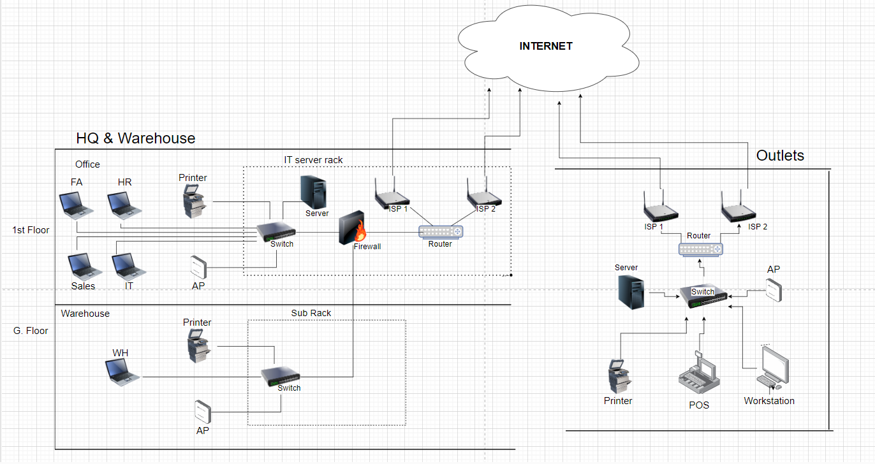

#### Hardware & Software Selection

The heart of any IT infrastructure is the selection of hardware and software solutions. The project's scope includes:

* **Workstations and Mobile Devices:** Investigation of the pros and cons of various workstations and mobile devices, assessing factors like performance, cost, and compatibility with UrbanVibe's software solutions & business direction.
* **Operating Systems & Software:** Exploration of the benefits and drawbacks of different operating systems and software, such as Microsoft Office, considering factors like user-friendliness and application support and familiar with local rules & regulation (on accounting & payroll software) when choosing global supplier.
* **Printing Solution :** exploring potential managed printer supplier that provide per click plan and leased printer.
* **Licensing and Cost Analysis:** Exploration of various licensing/Subscription/plan options and conducting a cost analysis to identify the most cost-effective solutions.
* **Cost-effectiveness:** Evaluate the cost-benefit ratio of different options to ensure the best value for investment.
* **Future-proofing:** Choose hardware and software that can be easily upgraded or expanded as the company grows.
* **Compatibility:** Ensure that hardware and software choices are compatible with existing systems and future technologies.
  + hardware & software procurement preference *Global presence, local support.*

#### Point-of-Sale (POS) System

The POS system is a vital component of UrbanVibe's retail operations. The project's scope includes:

* **POS Solutions:** Examination of different POS software options, preference to support cloud-based solutions. Analysis of their features, ease of use, and cost-effectiveness.
* **Offline Capabilities:** Ensure the POS system can operate offline to handle transactions during network outages.
* **Security and Compliance:** Exploration of POS system security measures, such as encryption and compliance with Payment Card Industry Data Security Standard (PCI DSS) requirements.
* **Payments Method:** Consideration of the pros and cons of various potential payment methods and considerate Merchant Bank offered MDR (Merchant Discount Rate)
* **Functionality:** Select POS systems that offer comprehensive functionality, including sales tracking, inventory management, and customer relationship management (CRM).
* **Integration:** Ensure seamless integration with other systems to streamline operations and data flow.
* **Future-proofing:** Choose hardware and software that can be easily upgraded or expanded as the company grows.
* **User-friendliness:** Choose POS solutions that are easy to use and require minimal training for staff.

By focusing on these key components and enhancements, UrbanVibe will be well-equipped to build a robust, secure, and efficient IT infrastructure that supports its business operations and future growth.

**2. Literature Review**

***2.1 Background of the study***

In recent years, technology has changed how fashion businesses work. For new fashion companies like UrbanVibe, using information technology (IT) is not just an option; it's a must for survival and growth. This review explores how technology and fashion are connected. It talks about why it's so important for new fashion businesses to use IT, going beyond thinking of it as a choice to show how necessary it is. The review looks closely at research and examples of what works well, trying to find the best ways to set up strong IT infrastructure that fit the needs of new fashion businesses. It looks at things like using servers, dealing with computer networks, choosing the right hardware and software, and planning how to use Point-of-Sale (POS) systems in a best way. This review wants to find insights that can help new fashion startup succeed in the fast-changing world where fashion and technology meet.

***2.2 Theoretical Framework***

In this section, we will explore practical examples and their applications to UrbanVibe IT infrastructure setup, covering server infrastructure, network design, hardware and software selection, and POS implementation.

***I. Server Infrastructure:***

Server infrastructure is a crucial component for any modern business, ensuring data storage, retrieval, and security. For UrbanVibe, establishing an efficient and reliable server infrastructure is paramount.

**Cloud vs. On-Premises Servers:** The debate between cloud-based and on-premises servers is a critical consideration. Research by Cameron Fisher, (2018) indicates that decision maker need to be incrasingly weigh the merits of cloud offering. scalability and cost-effectiveness of cloud solutions, might benefits UrbanVibe long run on Server infrastructure direction.

**Scalability and Flexibility:** the research integrates findings from Tiwari et al. (2018). Scalable solutions, as elucidated in the literature, not only accommodate business growth seamlessly but also contribute to cost reduction and sustained performance. The emphasis here is on crafting a server architecture that can evolve organically with the dynamic needs of a startup.

**Security:** The importance of server security in protecting sensitive data cannot be overstated. UrbanVibe should consider the latest security measures, including encryption, access controls, and regular vulnerability assessments on cloud computing (Gupta et al., 2020).

***II. Network Design:***

Efficient network design is vital for seamless communication and data transfer within the organization. In this section, we will discuss the following points:

**Network Topology:** the selection of an appropriate network topology stands as a critical determinant of operational efficiency and resilience. This research focuses on the evaluation and selection of network topologies—specifically star, mesh, and bus—analyzing their respective advantages and disadvantages in the context of UrbanVibe operational requirements (Ritu, 2017). the right type of network chosen really makes a big impact on UrbanVibe communication infrastructure.

**Bandwidth and Traffic Management:** A crucial element of managing networks well is making smart decisions about how to optimum and control the flow of data. The research will explore the managing data flow is so important for UrbanVibe, Quality of Service (QoS) methods and traffic shaping are seen as essential tools in making sure data gets allocated in the best way possible, taking inspiration from the research done by Qiao et al. (2018).

**Redundancy and Failover:** The research explores key areas related to redundancy and failover mechanisms in network structures. Through incorporating redundancy measures, UrbanVibe can strengthen the dependability of its network, reduce downtime, and improve overall business continuity. This study is in line with the discoveries of Vasumathi et al. (2019), highlighting the importance of giving extra attention to the redundancy and failover strategies.

**Network Security:** Protecting the network from threats is paramount. UrbanVibe should consider the latest security measures, such as study intrusion detection systems and firewalls which is in line with the discoveries of Zhang et al., (2018).

***III. Hardware and Software Selection:***

Selecting the right hardware and software is vital for UrbanVibe smooth operation. The following aspects should be considered:

**Hardware Procurement Strategies:** Research by Boudreau and Lakhani (2009) suggests that a combination of in-house and outsourced procurement can be cost-effective and efficient.

**Workstations and Mobile Devices:** Choosing the appropriate user devices is crucial for productivity. Mobile devices, laptops, and desktops should align with the organization's needs (Venkatesh et al., 2018).

**Operating Systems and Software:** Selecting the right operating systems and software solutions can have a significant impact on productivity and security (Doherty and Ellis-Chadwick, 2010). Open source vs. proprietary software is also a key consideration (Benlian et al., 2020).

Software Licensing and Compliance: UrbanVibe should be aware of the legal and financial implications of software licensing and ensure compliance with relevant regulations (Seddon and Currie, 2018).

***IV. POS Implementation:***

Choosing a Point-of-Sale (POS) system is a crucial determination for retail operations, and its repercussions extend to sales, inventory management, and customer engagement. This study delves into current literature, offering valuable insights into the essential factors influencing UrbanVibe on the selection of POS systems.

**POS Solution:** The research by Indra et al (2020) explores the key determinants influencing the perceived adoption of Point of Sale (POS) systems by SME. The study identifies critical factors on the decision-making process of these businesses in integrating POS technology into their operations.

**Payment’s method:** other than convention payment method, The widespread adoption of contactless payments has been expedited by the impact of the COVID-19 pandemic. UrbanVibe is contemplating the integration of contactless payment alternatives, prioritizing customer safety and enhancing convenience, as suggested by Büchi et al. (2020).

**Security and Compliance:** The research by by Yang.et al. (2007) focusing on vulnerabilities, threats, and countermeasures associated with these critical transactional platforms. POS systems handle sensitive financial data. Ensuring security and compliance with regulations like Payment Card Industry Data Security Standard (PCI DSS) is essential.

***Conclusion:***

The literature review presents a comprehensive overview of the research and best practices related to establishing IT infrastructure for a startup fashion company. It highlights the critical aspects of server infrastructure, networking design, software selection, and the implementation of POS systems. The research and insights from existing studies provide valuable guidance for the project, offering a roadmap for the successful integration of IT within the fashion industry. By following these best practices, fashion startups can enhance operational efficiency, data security, and customer experiences, ultimately positioning themselves for success in a rapidly evolving digital world.

**Chapter 3: Methodology**

The ***Waterfall Approach*** is a linear and sequential project management methodology that is widely used in IT projects. It divides the project into distinct phases, each of which must be completed before the next phase begins. For UrbanVibe, the Waterfall approach provides a structured framework for implementing the IT infrastructure from scratch, ensuring each step is thoroughly planned and executed.

The main phases in the Waterfall model are:

1. ***Requirements Analysis***
2. ***System Design***
3. ***Implementation***
4. ***Testing***
5. ***Deployment***
6. ***Maintenance***

Each of these phases is critical to the success of the project, and careful planning and execution are required to ensure a smooth transition from one phase to the next.

#### Phase 1: Requirements Analysis

The Requirements Analysis phase is the foundation of the Waterfall approach. In this phase, I’ll gather detailed information about the project's requirements from stakeholders and end-users. This phase aims to create a comprehensive understanding of what the project needs to achieve and the specific requirements that must be met.

**Activities:**

* ***Surveys:***Distribute detailed surveys to all users to collect quantitative data on their IT usage, preferences, and pain points. Surveys will include questions on hardware performance, software applications used, network reliability, and overall user satisfaction (Fowler, 2013).

IT requirement survey for HQ and Store are send to respective user via google form to collect the essential information to analysis. (*Appendix UrbanVibe IT requirement Survey Questionnaire)*

* ***Interviews / Meeting:***the data collection from the survey mostly can after analysi can be treat as basic information, there will be a need toconduct one-on-one interviews with key stakeholders in each department (Finance & Admin, Human Resources, Sales, IT, Warehouse). These interviews will help gather qualitative data about the current IT setup, challenges faced, and specific requirements.
  + **Finance & HR Needs:** Identify the spec of computers and specific software. (Accounting & HRMS)
  + **IT Needs:** require advance router & firewall and specific administrator software to monitor overall network & system performance.
  + **Warehouse Needs:** Determine the requirements for durable machines and inventory management software.
  + **Outlet Needs:** Establish the need for a robust POS system that works both online and offline, with real-time data synchronization.

***Phase 2: System Design***

The System Design phase involves creating a detailed blueprint for the IT infrastructure, based on the requirements gathered in the previous phase. This phase translates the documented requirements into a comprehensive system design that includes hardware, software, network, and security specifications.

**Activities:**

* **Network Design:** Develop a network architecture that includes the layout of the HQ, warehouse, and outlets. This should segmented network with VLANs for each department, a secure VPN for remote outlets, and redundant internet connections for reliability. The task including identify how many VLAN are needed on the company network design.
* **Server Configuration:** one of the UrbanVibe IT strategies is leveraging cloud-based services which foreseen can provide significant operational and strategic advantages, enabling faster growth, agility, and cost-effectiveness in a competitive market environment.

Hence, there will be no server to be install in HQ or Store.

* **Hardware and Software Specifications:** Select the appropriate hardware and software for each department, ensuring compatibility and meeting user requirements. Which include identify the local specific software (Accounting & Payroll) and POS solution / Supplier which are familiar with local rules and regulation.

***Phase 3: Implementation***

The Implementation phase involves the actual deployment of the designed IT infrastructure. This phase is focused on setting up and configuring hardware and software according to the design specifications.

**Activities:**

* **Infrastructure Installation:** Set up basic but fundamental component such as network cabling, server rack, inter-tie network, power supply, UPS, etc
* **Hardware Installation:** Install and configure hardware at the HQ, such as workstations, Access point and printer in each department, and deploy POS systems at the outlets.
* **Software Deployment:** Install and configure necessary software, including Mircosoft 365, Active Directory, Email Exchange, accounting software, and HRMS
* **Network Setup:** Configure routers, switches, access points, and establish VPN connections between remote outlets and the HQ.
* **POS Solution :** the awardedPOS solution provider is require comprehensive cover from setup the POS terminal, configure POS Software at store and all peripheral and provide after sales support. a.k.a one stop solution on handling all POS matters.

***Phase 4: Testing***

The Testing phase is critical to ensure that the implemented IT infrastructure meets all specified requirements and functions correctly.

**Activities:**

* **Network Testing:** Test network performance, security, and reliability, ensuring all segments and connections operate as designed.
* **Workstation Testing:** Validate that workstations in each department run the necessary software and perform as expected.
* **POS System Testing:** Perform functionality tests on the POS systems to ensure they work both online and offline, and that data synchronizes correctly with the HQ server.

#### Phase 5: Deployment

The Deployment phase involves rolling out the tested IT infrastructure to all locations.

**Activities:**

* **Deployment Planning:** Develop a detailed deployment plan that outlines the steps for rolling out the new infrastructure. staggered roll out the new infrastructure in phases, starting with the HQ, followed by the warehouse, and then the outlets, to manage and resolve any issues incrementally.
* **Go-live:** Provide on-site and remote support during the initial go-live phase to address any immediate issues or user concerns.
* **User Training:** Conduct training sessions for staff in each department, ensuring they understand how to use the new workstations, software, and POS systems.

#### Phase 6: Maintenance

The Maintenance phase is ongoing and involves providing support and updates to ensure the IT infrastructure continues to meet business needs and remains effective & efficient

**Activities:**

* **Helpdesk Support:** as the current size of the company and limited budget, all IT relevant incident will fully park under local IT team
* **Regular Maintenance:** Schedule regular maintenance windows for software updates, hardware inspections, and network optimizations.
* **Continuous Improvement:** Continuously gather feedback from users to identify areas for improvement and implement necessary changes to keep the IT infrastructure aligned with business needs.

***Chapter 4: Design & Implementation***

***4.1 Design of IT Architecture***

The design of UrbanVibe IT architecture is critical to ensure a robust, scalable, and secure infrastructure that supports the company's operations across HQ, warehouse, and stores. This section presents a detailed design of the IT architecture, including network topology, server configuration, security measures, and data backup and recovery plans.

##### Network Topology for HQ, Warehouse, and Outlets

To design a network that ensures efficient communication, data flow, and security across all locations.

***HQ Network Topology:***

* **Layout:** The HQ network is segmented into VLANs for each department (Finance & Admin, Human Resources, Sales, IT) and the warehouse.
* **Core Switch:** A high-performance core switch connects all VLANs, ensuring efficient data flow and management.
* **Access Points:** Wireless access points (WAPs) are strategically placed to provide robust Wi-Fi coverage across the HQ.
* **Internet Connection:** Dual ISP connections provide redundancy, ensuring continuous internet access.

**Warehouse Network Topology:**

* **VLAN:** The warehouse has a dedicated VLAN to separate its network traffic from other departments.
* **Wireless Coverage:** WAPs are fully covered warehouse to ensure seamless Wi-Fi coverage for inventory management systems need.
* **Access Control:** Network access control (NAC) mechanisms are implemented to ensure only authorized devices can connect.

**Outlets Network Topology:**

* **VPN Connection:** Each outlet is connected to the HQ via a secure VPN, ensuring secure data transmission.
* **POS Network:** A dedicated network segment for POS systems ensures reliable transaction processing.
* ***Redundancy: Local backup internet connections are provided to maintain POS functionality during ISP outages.***

***HQ & Warehouse Premise network cabling Plan***

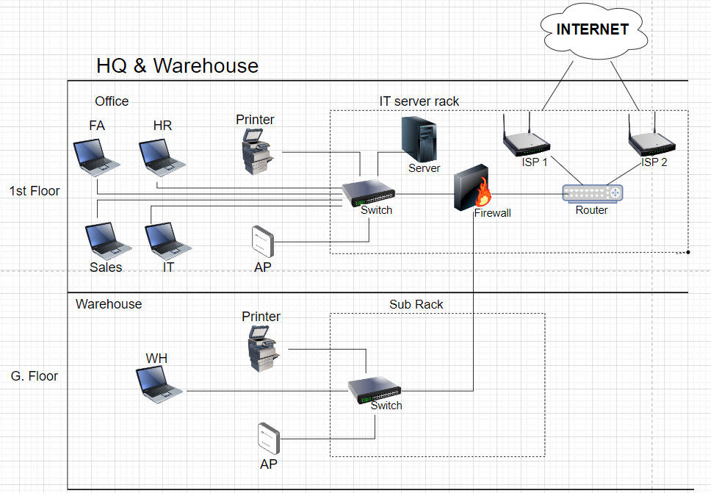

**Outlet Premise network cabling Plan**

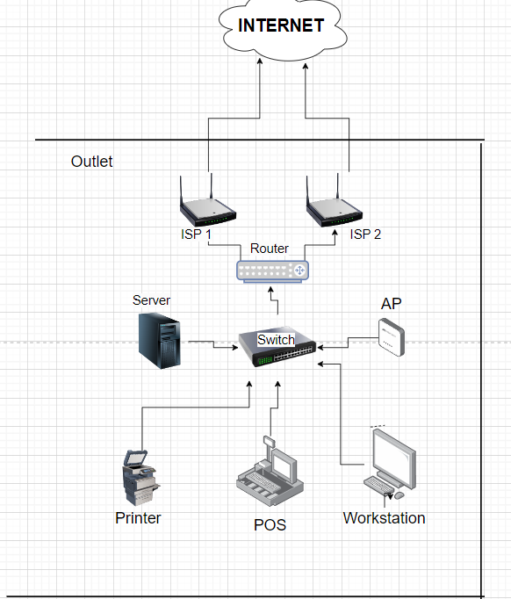

##### Server Configuration and Setup

UrbanVibe don't need to set up any on-premises servers at HQ to manage domain and identity, as these can be fully handled through cloud-based services (Microsoft Azure & 365) which meet the most needs of UrbanVibe as well reduce the digital carbon foot print as one of the company contribution to ***CSR*** *(Corporate Social Responsibility)*

**HQ/Warehouse Server Configuration:**

* **Cloud-based/ SaaS :** The Core business productivity are powered by cloud base.(Mircrosoft 365 Business Standard Plan) and the other’s local need software are Accounting QuickBooks Online and HR - Info-TechSoftware as a Service (SaaS).
* **Storage & Backup server :** all work related data & file either stored at OneDrive or SharePoint Online while POS data are store at POS supplier end Cloud-based host.

**Outlet Server Configuration:**

* **POS Server:** the proposed POS solution are one stop solution where from POS server to POS terminal and other relative peripheral as supplied & Configured by POS vendor (StoreHUB).

##### Security Measures

To implement security measures that protect UrbanVibe IT infrastructure from threats and ensure secure data transmission.

**Firewall Protection:**

* **HQ Firewall:** A Cisco ASA 5500x series Firepower Threat Defense (FTD) is deployed at the HQ to manage and secure incoming and outgoing traffic. The advanced security policies, including intrusion prevention, web filtering, and application control.
* **Outlet Firewalls:** outlet is equipped with a Cisco Meraki MX65W to provide local network security and secure VPN connections to the HQ.

**VPN Setup:**

* **Site-to-Site VPN:** Secure VPN tunnels are established between the HQ and outlet, using IPSec protocols to encrypt data transmission.

**Endpoint Security:**

* **Antivirus Software:** Trend Micro Antivirus is installed on all workstations and servers to protect against malware and other threats. Trend Micro Worry-Free plan provides real-time protection and regular security updates for all endpoints.
* **Access Controls:** Role-based access controls (RBAC) are implemented to ensure users only have access to the resources they need.

***4.2 Construct of System & Network***

The construction phase of UrbanVibe IT infrastructure involves setting up workstations and peripherals, installing and configuring servers, network setup, and deploying POS systems in outlets. This section provides a detailed practical example of each of these tasks to ensure a comprehensive understanding of the implementation process.

##### 1) Setting up Workstations and Peripherals

To provide all departments with the necessary hardware and peripherals to perform their daily tasks efficiently.

**Activities:**

**General deployment** : Assign HP Elitebook 840 G8 with Windows 11 and a monitors with built in docking feature, Miro Trend Worry-Free Anitivirus for end point security.

**Specific need :**

* **Finance & Admin:** Dedicated install Accounting software (SQL Accounting).
* **Human Resources:** Dedicated install HR Management Software. (HR2000 i-Payroll)
* **Printer Solution :** Canon Smart eService with network printer model imageRUNNER ADVANCE DX C3900iwill fullfill all user demand On top of the core function work as network printer, it also have the secure printing for HR dept where all send job will require sender login to release the printing (by tapping the card access on the card reader on the printer) (*Appendix AP_C4.2_01*). Scan & Email feature also fullfill HR and FA dept the need of scanning hardcopy document and store in softcopy. UrbanVibe IT will need to allocate the correct vacant port during Canon setup the printer at Office and Warehouse. *Early Detection and Prevention* is a feature that allow retrieve the consumable part remaining days /volume and notify Canon to perform part replacement without disrupting user print job.

**2) Fundamental Infrastructure :**

Setup essential infrastructure such cabling, IT room , UPS that are essential to support company System and Network.

**Activities:**

* **Cabling :** Laying CAT6a cable for all HQ and Warehouse end user device as well as the interconnection between Server Rack and Sub Rack. Cat6a can support 10 Gigabit Ethernet at lengths up to 100 meters which suite to work as the medium of inter tie of two switches.
* **Server Rack** : install a 42U Server rack with perforated door where all LAN cable will be terminated at the patch panel. And a 4U wall mount sub rack will install at warehouse dept to placing the 2nd switch which cover warehouse connection.
* **Uninterruptible Power Supply**  : a 3kVA UPS will be installed in server rack as surge protecter and backup for the entire rack equipment need. another 1Kva UPS for same purpose will installed to protect sub rack IT equipment at warehouse area.
* **Safety** : a CO2 fire extinguisher will be placed at outside of the IT room entrance instead installing of FM 200 system which much costly and for larger server room.
* **Power Supply** : all incoming live source will be connected to the UPS instead direct supply to server rack Power Distribution Units(PDU), this avoid interruption when live source cut off.

***HOW TO…Implement fundamental infrastructure***

This section will showcase the implementation of fundamental setup in UrbanVibe HQ, Warehouse & Outlet are breaking into 3 stage

### Stage 1: Pre-Installation Preparation

1. **Site Survey and Assessment**:
   * Conduct a thorough site survey to understand the physical layout i.e the distance of Main rack (1st Floor) and sub-rack (ground) and identify potential challenges.
   * Assess the requirements for cabling lengths, types, and routes.
2. **Planning and Design**:
   * Create a detailed network design document, including the cabling plan (*Appendix AP_C3.2_01*), device placement (Furniture – Workdesk, cabinet), and labeling scheme. *For instance : GF-01 – Ground Floor, Data Point outlet 01, 1F-01 - 1st Floor Data Point outlet 01*
   * Ensure compliance with local regulations and industry standards. Include placing Bomba approved Fire extinguisher at Server room
3. **Procurement**:
   * Order the necessary materials, including Cat6 cables, connectors, patch panels, UPS switches,, routers, firewalls, and server racks.
   * Ensure all equipment is compatible and meets the required specifications. A specific rack that suite network equipment measurement.

### Stage 2: Infrastructure Setup

1. **Cable Pathway Installation**:
   * Install cable trays, conduits, and raceways to support the network cables installing in next stage.
   * Ensure pathways are secure, accessible, and do not interfere with other cables. (*Appendix AP_C3.2_04*)
2. **Server Rack and Sub Rack Setup**:
   * Assemble and install the main server rack (*Appendix AP_C3.2_11*) on the 1st floor and the sub rack in the ground floor warehouse.(*Appendix AP_C3.2_12*)
   * Mount switches, patch panels, and other networking equipment in the racks.
   * All hardware are connected to the rack Power Distribution Unit (PDU) with UK Plug spec (*Appendix AP_C3.2_06*)
3. **Power Supply Setup**:
   * TNB electricity supply will connect to the UPS with Automatic Transfer Switch (ATS). where in the situation the UPS are faulty, the UPS ATS module will turn on and allowing the Main eletricity supply power skipped the UPS unit direct power to PDU. (*Appendix AP_C3.2_07*)

### Stage 3: Cabling Installation & testing

1. **Horizontal Cabling**:
   * Run Cat6 cables from the main server rack to each department on the 1st floor I.e FA, HR, Sales & IT. Data point and patch Panel wiring (*Appendix AP_C3.2_10*)
   * Route cables from the sub rack to the warehouse workstations, printers and AP port.
2. **Vertical Cabling**:
   * Install vertical cabling to connect the server rack on the 1st floor with the sub rack in the warehouse. (*Appendix AP_C3.2_04*)
   * Use structured cabling techniques to ensure neatness and ease of maintenance. Where the CAT6 cable wiring are refer to T-568A standard. (*Appendix AP_C3.2_09*)
3. **Termination and Labeling**:
   * Terminate cables at both ends with appropriate connectors (RJ45).
   * Label each cable and port for easy identification and troubleshooting. (*Appendix AP_C3.2_05*)

**4. Cable Testing**:

* + Use a cable tester (*Appendix AP_C3.2_08*) to verify the integrity and performance of each cable.
  + Ensure all connections are secure and meet the required standards. (*Appendix AP_C3.2_09 & AP_C3.2_10*)

**3) Installing and Configuring Software**

UrbanVibe IT strategies is toward fully cloud-based environment (Saas) on core productivity tool (Mirocoft 365, Active Directory, Accounting & HRMS).

**Activities:**

* **Initial Setup :** Configure Azure Active Directory, setup company domain, link Azure to Microsoft 365
* **SaaS :** As the Accounting software (QuickBook Online) and HR management software (INFO-TECH) are fully cloud-base platform where no host machine require in UrbanVibe HQ. UrbanVibe only need to ensure the Laptop browser are compatible with the software version. (*Appendix Software as a Server (Saas) Vendor list for UrbanVibe*)

**4) Network Setup (Routers, Switches, Access Points)**

To establish a reliable and secure network infrastructure that connects all locations and devices.

**Activities:**

* **HQ & Warehouse Network:** Install a Cisco ISR 4331router (*HQrouter*) for to manage internet connectivity, internal routing, and VPN connections between the HQ and outlets.

Cisco ASA 5605 Firewall provide the security measure such as controlling inbound and outbound traffic and Intrusion Prevention (IPS). *Security level-100* has been assigned to inside interface while *Security level-0* was configure to outside interface.

2 x Cisco Catalyst 3560 Switch (*SOswitch & WHswitch*) setup to connect all workstations and peripherals (printer & AP) within each location rack. VLANs implemented to segment network traffic for different departments (*VLAN 20 – HR, VLAN 30 – Sales, VLAN 40 – IT, VLAN 50 – Warehouse, VLAN 70 – FA, VLAN 100 Wireless entwork (AP) and VLAN 110 - Printer*) enhancing security and performance.

Cisco Aironet Access Point will deploy to multiple strategy location to provide robust Wi-Fi coverage throughout the HQ and Warehouse area.

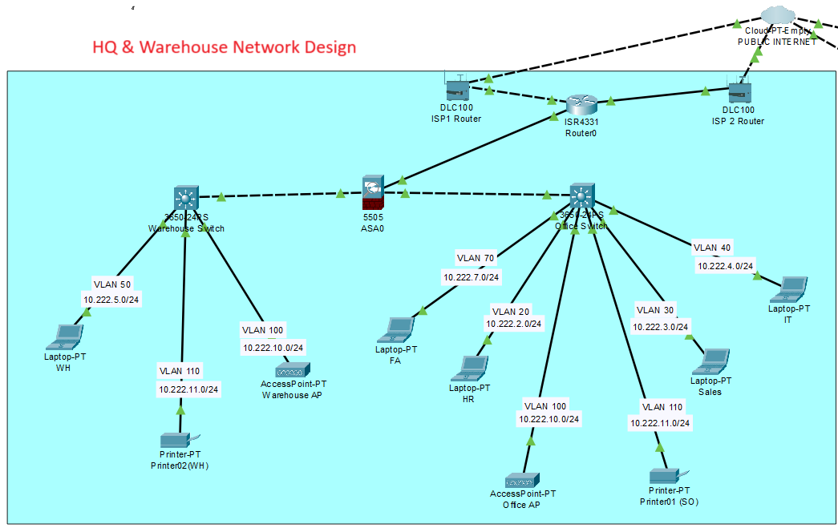

* **Outlet Networks:** Cisco Meraki MX65W will setup in store to establish secure VPN connections to the HQ, The MX65W are Connected 2 different internet lline (ISP1 and ISP2) for internet redundancy.
* Cisco Catalyst 3560 switch will be setup in warehouse area to connect all POS system, servers, and peripherals. 2 VLANs implemented to segment network traffic for different usage (*VLAN 10 – POS, VLAN 20 – BO).* Where VLAN *POS* are designed for POS/sales relevant traffic, which include EFT traffic while VLAN BO are for Back Office peripheral also known as *NONE Sales* traffic. I.e PC, printer, AP etc.

Cisco Aironet 3800 series Access Point will deploy to multiple strategy location within the store to provide customer free wifi.

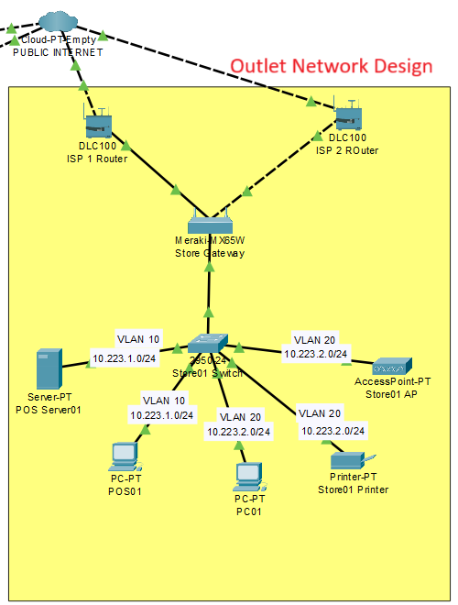

##### 5) POS System Deployment in Outlets

set up and configure POS systems in outlet, ensuring they can operate both online and offline.

**Activities:**

* **POS Installation:** local POS Supplier (StoreHub) awarded as the principle supplier on supplying POS terminals, receipt printers, barcode scanners, and cash drawers at outlet. As well configure POS software to ensuring it integrates with the UrbanVibe CRM apps.

POS systems are are allowed function in offline mode, allowing basic sales operations to continue during network outages. (*Appendix AP-C4.2-POS*)

* **Credit Card terminal Setup : Merchant Bank technician will help to setup the card card terminal while UrbanVibe ensure the EFT are linked to POS interface.**
* **Network configuration:** UrbanVibe IT team has configure two Vlan for two categories accessing on connect POS terminals to the local network and configure at Cisco Switch to ensure it able synchronize data with the Cloud server and able to access internet.

Outlet subscribed 2 different ISP internet (300MB) for Core application (POS, Email, etc) and Free Wifi consumption.

* **Store WIFI** : outlet are installed AP to provide free WIFI to customer for better shopping experiences.
* **Store back office :** Set up HP Pro Small Form Factor 400 G9 Desktop PC, licensed PC with Microsoft 365 plan to allow store management team to able to communicate with Email, messaging, video & Audio call via Microsoft Teams,

***4.3 Testing***

Testing is a crucial phase in the implementation of UrbanVibe IT infrastructure. It ensures that all systems, networks, and devices function as expected and meet the specified requirements. This section outlines the practical procedures for functional testing of workstations and peripherals, network connectivity and performance testing, POS system functionality, and data synchronization tests between outlets and HQ.

***Functional Testing of Workstations and Peripherals***

To ensure that all workstations and peripherals function correctly and meet the needs of end users.

**Activities:**

* **Hardware Functionality:** Test all components of the workstations (CPU, RAM, storage, display, keyboard, mouse) to ensure they are working properly.

- By test running multiple application simultaneously (Client version Office Excel, Word, Teams, Outlook) and accessing SaaS via browswer

* **Peripheral Integration:** 1) Verify the network printers able to send job from office and collect it from warehouse printer and vice versa. Test sending print job only can be release by sender card access at printer. Verify Scan & Email are receive at sender email inbox. Including request Canon end test the eservice connection are reaching the printer at site. 2) user laptop are remain connected to company WIFI no matter user roaming from office to warehouse and vice versa.
* **Software operation:** Confirm that all necessary software – MS 365 and especially the local Web based software I.e QuickBook Online and Info-Tech is operating without issues by accessing from different work location (Anywhere & Anytime). Sales personnel are able to retrieve the sales & stock data from StoreHUB cloud host.
* **User Accounts and Permissions:** Test user account creation, login, and access permissions to ensure security and appropriate access levels.

**Network Connectivity and Performance Testing**

To ensure that the network infrastructure is reliable, secure, and performs optimally.

**Activities:**

* **HQ Network:** Use Wireshark to verify latency and packet loss, and ensure access points provide robust Wi-Fi coverage.
* **Warehouse Network:** Test connectivity between the warehouse VLAN and HQ, ensure Wi-Fi coverage is seamless, and verify that inventory management systems can communicate with the central servers. **(*Appendix AP_C4.3.01*)**
* **Outlet Networks:** Measure VPN performance between outlets and HQ, test local network speed and reliability, and verify secure network configurations.

**POS System Functionality.**

To ensure that POS systems at the outlets function correctly both online and offline, providing reliable service to customers.

**Activities:**

* **Online Functionality:** Test POS system functions (sales, returns, inventory checks) by Conduct transactions, process returns, and perform inventory checks while connected to the network, ensuring all data is accurately recorded and transmitted to the HQ.
* **Offline Mode:** Simulate network outages and test POS system functions to ensure basic operations can continue without network connectivity. Reconnect to the network and confirm that all offline transactions are synchronized with the HQ server.
* **Data Synchronization:** Verify that data (sales transactions, inventory updates) are correctly synchronized with the HQ server once connectivity is restored.
* **User Interface Testing:** Ensure the POS interface is user-friendly and that all functionalities are easily accessible.

**Data Synchronization Tests**

To ensure that data synchronization between the outlets, HQ and SaaS host is accurate, timely, and reliable.

**Activities:**

* **Transaction Synchronization:** Conduct sales transactions at the outlets, verify that the data is transmitted to the HQ system in real-time, and ensure accuracy and completeness of the data.
* **Inventory Synchronization:** Perform inventory updates at the outlets, confirm that changes are reflected in the central inventory system, and ensure no data discrepancies.
* **EOD Reports:** Generate EOD sales reports at each outlet, automate their transmission to the HQ server, and verify the accuracy of the reports.
* **Error Handling:** Disconnect the network during synchronization, resolve the network issue, and ensure the system can recover and synchronize any missed data without errors.

**Chapter 5: Conclusion and Recommendation**

***5.1 Conclusion***

The successful implementation of the IT infrastructure for UrbanVibe marks a significant milestone in the company's journey towards operational excellence and growth. This project aimed to build a robust, scalable, and secure IT environment from scratch, supporting the various business functions across the headquarters, warehouse, and geographically dispersed outlets. The comprehensive approach taken in this project ensures that UrbanVibe is well-equipped to handle its current operational needs and is prepared for future expansion and technological advancements.

**Key Points of the Project**

**Comprehensive Needs Assessment:** The project began with a thorough assessment of UrbanVibe IT needs. This involved understanding the specific requirements of each department, evaluating the existing technological landscape. The needs assessment laid the foundation for designing an IT infrastructure that is tailored to UrbanVibe business objectives and operational workflows.

**Strategic Design of IT Architecture:** The design phase focused on creating a detailed blueprint of the IT architecture, including network topology, server configurations, security measures, and data backup plans. The design ensured that all components were aligned with best practices for performance, reliability, and security. Special attention was given to network segmentation, redundancy, and scalability to support future growth.

**Robust System and Network Construction:** The construction phase involved setting up workstations and peripherals, installing and configuring servers, and establishing a secure and efficient network. Each department was equipped with the necessary hardware and software to perform their tasks efficiently. The network infrastructure well planned and implemented, ensuring seamless connectivity and optimal performance across all locations.

**Thorough Testing Procedures:** Testing was crucial to make sure the IT setup worked well and was reliable. We thoroughly tested workstations, servers, network parts, and POS systems. Functional testing checked that everything worked as users needed, and performance and security testing ensured the network was strong and safe. Completing these tests successfully confirmed that our solutions were effective.

**Seamless POS System Deployment:** The deployment of POS systems in the outlets was a significant achievement. The POS systems were configured to operate both online and offline, ensuring continuous sales operations even during network outages. Data synchronization between the outlets and the HQ was tested thoroughly to ensure real-time accuracy and reliability. This deployment has enhanced the efficiency and reliability of sales operations across UrbanVibe retail network.

***5.2 Recommendation***

As the company continues to grow and evolve, it is essential to keep the IT infrastructure up-to-date and aligned with emerging technologies and business needs. The following recommendations will help UrbanVibe maintain a competitive edge, enhance operational efficiency, and support sustained growth.

**Upgrading Hardware as the Company Grows**

As UrbanVibe expands, the demand for more powerful and efficient hardware will increase. Upgrading hardware ensures that the IT infrastructure can handle increased workloads and maintain optimal performance.

**Recommendations:**

1. **Scalability Planning:** upgrade plan that aligns with UrbanVibe growth projections. This plan should include periodic assessments of current hardware capabilities and future requirements.

Including upgrade Mircosoft 365 plan higher package which more productive tools.

1. **Server Upgrades:** Invest in more powerful servers with higher processing power, memory, and storage capacity to support expanding business operations and data volumes. Include considerate to virtualization server
2. **Workstation Enhancements:** Regularly update workstations to keep pace with the latest advancements in technology, ensuring that employees have access to the best tools for productivity.
3. **Peripheral Upgrades:** Upgrade printers, scanners, and other peripherals as needed to maintain efficiency and compatibility with new software and systems.

**Regular IT Audits and Updates to Maintain System Security and Efficiency**

**Rationale:** Regular IT audits and updates are essential to identify potential vulnerabilities, ensure compliance with security standards, and maintain overall system efficiency.

**Recommendations:**

1. **IT Audits:** Conduct regular IT audits to evaluate the effectiveness of security measures, identify potential risks, and ensure compliance with industry standards.
2. **Security Updates:** Implement a schedule for regular security updates and patches to protect against cyber threats and vulnerabilities. Include upgrade Cisco Firewall to latest model but subject to allocate budget.
3. **System Performance Reviews:** Periodically review system performance to identify areas for improvement and optimize resource utilization.
4. **Disaster Recovery Testing:** Regularly test disaster recovery plans to ensure they are effective and can be executed smoothly in case of an emergency.

***References***

* Few, S. (2013). Information dashboard design: Displaying data for at-a-glance monitoring (2nd ed.). Analytics Press.
* Fowler, F. J. (2013). Survey research methods (5th ed.). SAGE Publications.
* Qualitative Sozialforschung/Forum: Qualitative Social Research, 6(2), Art. 43.
* Montgomery, D. C., Jennings, C. L., & Kulahci, M. (2015). Introduction to time series analysis and forecasting. John Wiley & Sons.
* Rea, L. M., & Parker, R. A. (2014). Designing and conducting survey research: A comprehensive guide (4th ed.). Jossey-Bass.
* Sequeira, K., & Desai, R. (2019). Analyzing network traffic for network forensics. International Journal of Computer Applications, 177(33), 1-6.
* Cameron Fisher, (2018). *Cloud versus On-Premise Computing*
* Tiwari, V., Pateriya, R. K., & Tiwari, V. (2018). *Scalable Cloud Computing Services*.
* Saurabh Gupta, Rani.S. Batra.k, (2020). *Maximal Security Issues and Threats Protection in Grid and Cloud Computing Environment*
* Gupta, R., Pandey, B., Mishra, M., & Maurya, N. (2020). *Security threats, challenges, and solutions in cloud computing.*
* Ritu. (2017).*Study of Different Network Topologies,* International Journal of Advanced Research in Electrical, Electronics and Instrumentation Engineering
* Qiao, D., Kim, H., & Ameigeiras, P. (2018). *Traffic Shaping and Policing.* In Network Coding at Different Layers in Wireless Networks
* Vasumathi, A., Shalini, P., & Saravanan, M. (2019). *Efficient Network Topology with Minimal Latency.* In Innovations in Computer Science and Engineering
* Zhang, S., Du, Y., Guizani, M., & Zhang, Y. (2018). *Network Security for Internet of Things: A Survey.* IEEE Internet of Things Journal
* Boudreau, K. J., & Lakhani, K. R. (2009). *How to manage outside innovation.* MIT Sloan Management Review
* Venkatesh, V., Thong, J. Y. L., Xu, X., & Tam, K. Y. (2018). *Consumer acceptance and use of information technology: extending the unified theory of acceptance and use of technology.* MIS Quarterly
* Doherty, N. F., & Ellis-Chadwick, F. (2010). *Exploring the drivers of online shopping: A focus on tertiary versus non-tertiary students.* Marketing Review
* Benlian, A., Hilkert, D., Winkler, T. J., & Veit, D. (2020). *Information Systems Security, Reconsidered: An Explication of the Research Landscape.* Journal of Management Information Systems
* Seddon, P., & Currie, W. (2018). *A model of IS/IT outsourcing risk. J*ournal of Information Technology
* Indra Y., Arinda P., Sylviana.D., Tarindra.R. (2020) *The determinants of point of sales system adoption perceived by micro small medium enterprises in West Java, Indonesia*
* Wang, Y., Wu, L., & Wang, S. (2017). *The evolution of sales forecasting using prediction markets.* International Journal of Forecasting
* Yang.C., Tain.G., Ward.S., (2007) *Security systems of point-of-sales devices*

***Appendices:***

Cable Tray with network Cables (AP_C3.2_04) Network Cables in server rack (AP_C3.2_04)

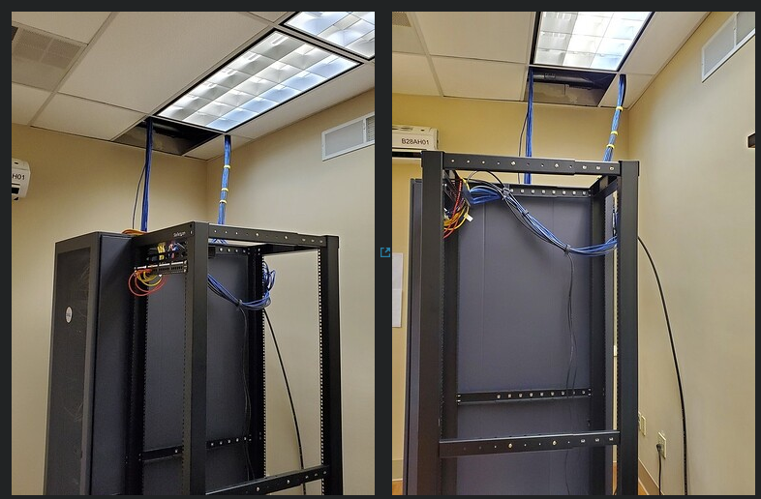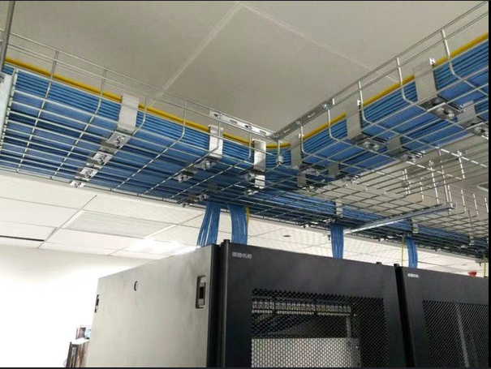

Network Cables labeling & patching (AP_C3.2_05) PDU with UK plug (AP_C3.2_06)

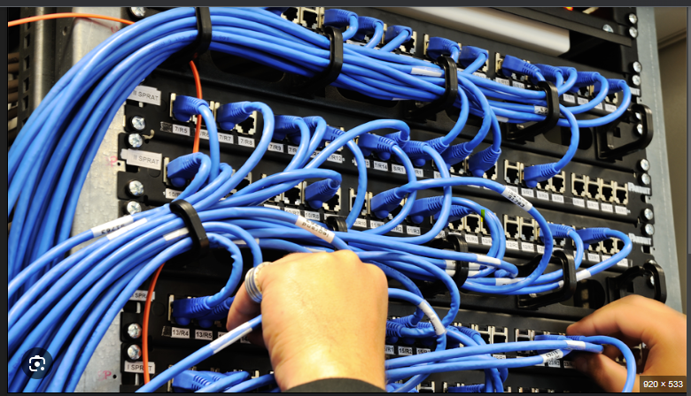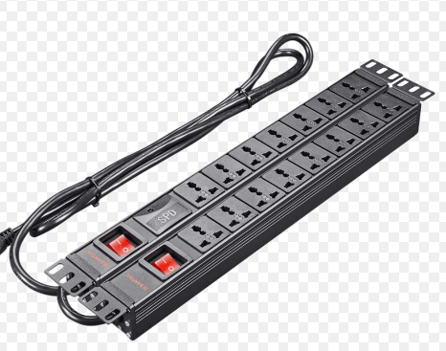

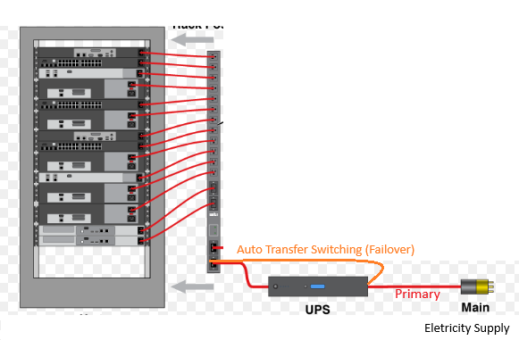UPS with Auto Transfer Switching (AP_C3.2_07)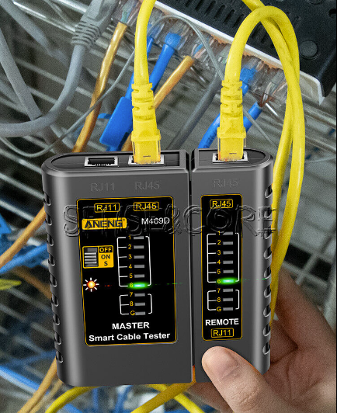 LAN network cable tester (AP_C3.2_08)

CAT6 wiring (AP_C3.2_09) Patch Panel wiring (AP_C3.2_10)

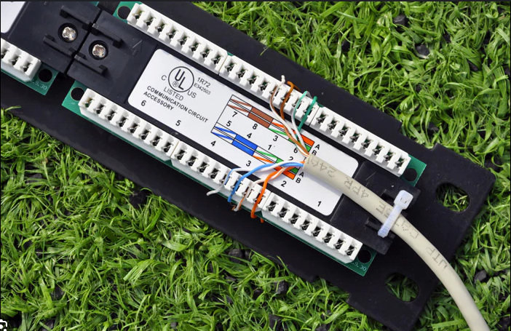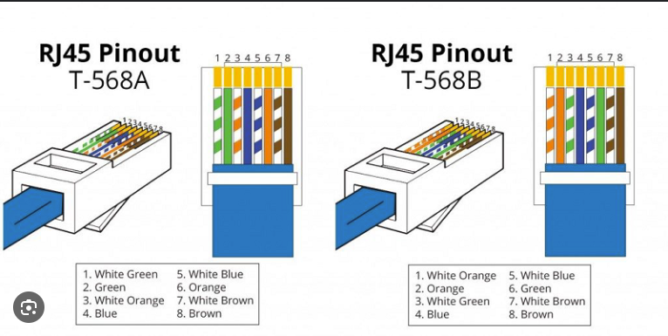

42U proforated type server rack (AP_C3.2_11) 4U Wall Mount server rack (AP_C3.2_12)

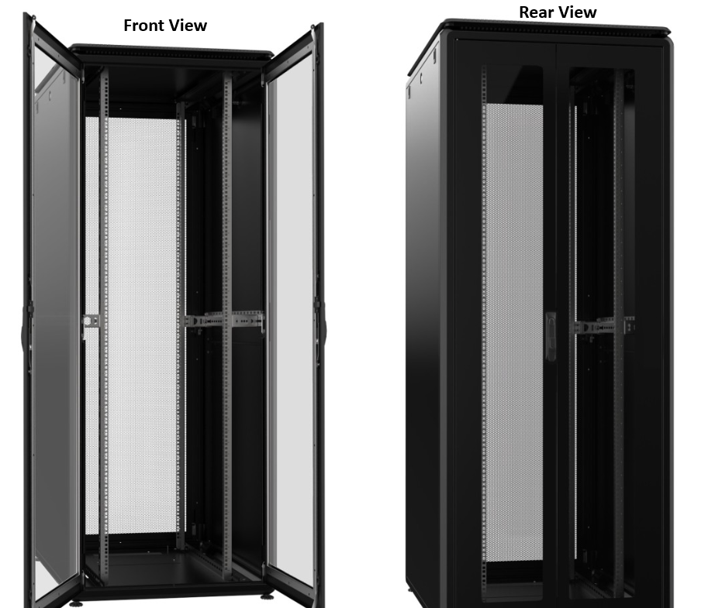

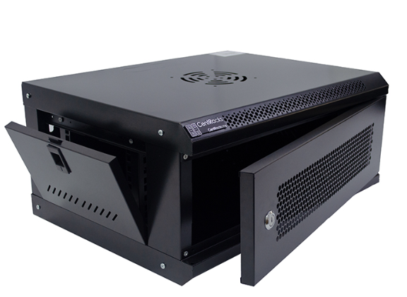

**Canon All in One Printer + Card Reader feature (AP_C4.2_01)**

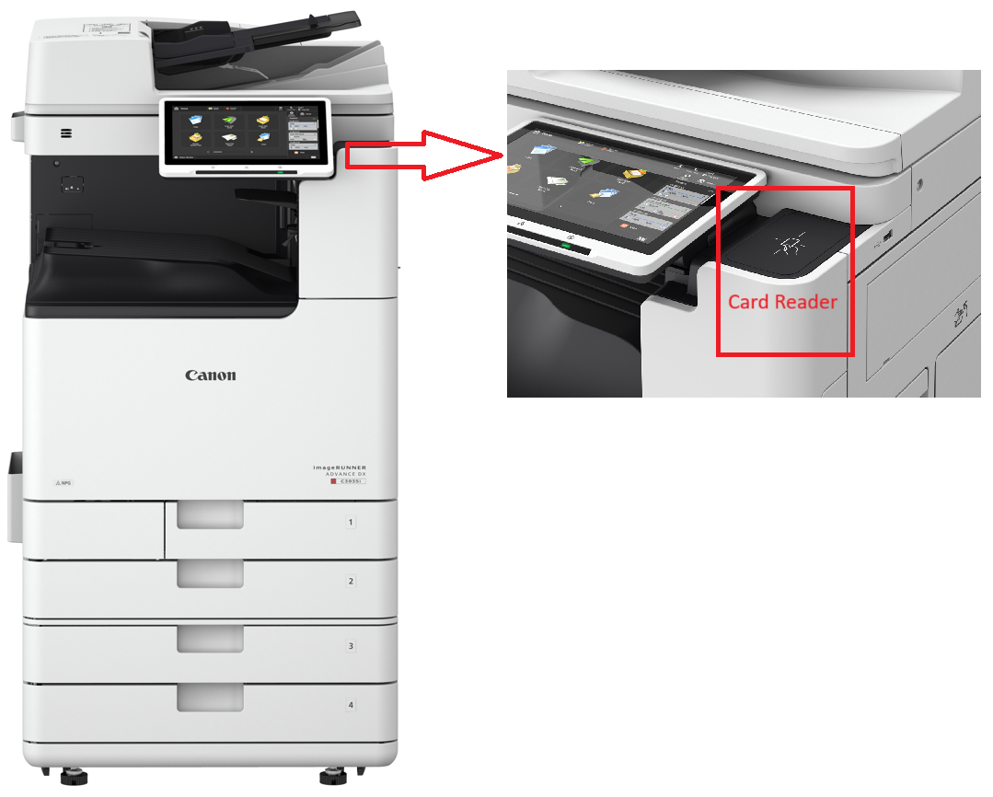

**HQ Switch Vlan segment and port trunk configuration (AP.C4.3.01)**

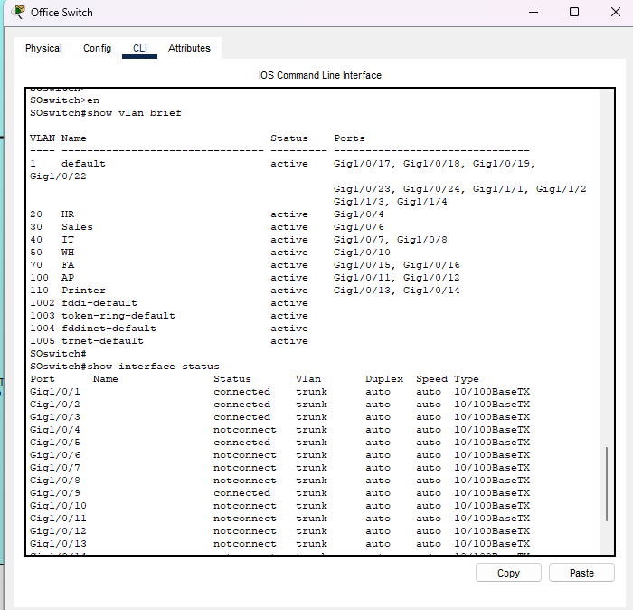

The StoreHub – (AP-C4.2-POS)

StoreHub is an all-in-one platform that enables retailers and restaurants across Southeast Asia to automate and grow their businesses.

StoreHub provides an ecosystem of solutions ranging from a cloud-based POS system, to QR-based table ordering, loyalty, customer engagement, and more.

StoreHUB - **Sunmi T2**

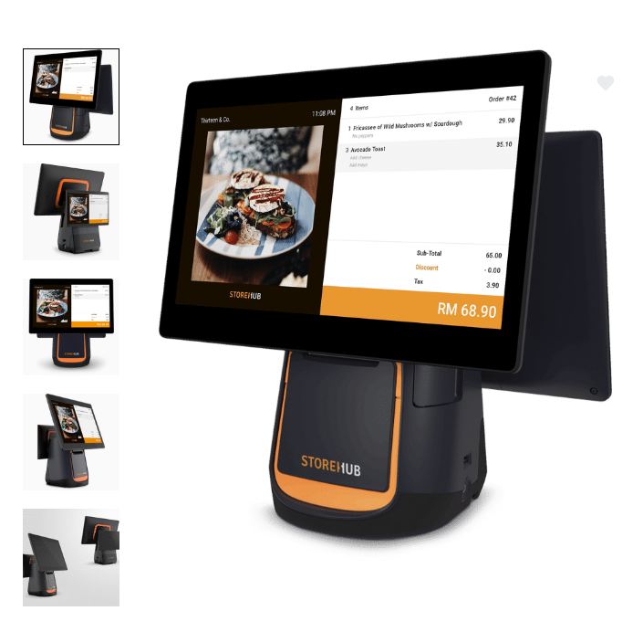

### **PRODUCT DESCRIPTION**

Display - **15.6"+10.1"**

Power Adapter - **Input: AC100~240V/1.7A , Output: DC24V/2.5A**

Automatic cutter - **Equipped**

Paper roll - **80mm**

Memory - **2GB RAM + 16GB ROM**

Dimensions - **407mm*382mm*232mm**

External Port - **USB Type A port×5, RJ11 serial port×1, RJ12 cash drawer port×1,**  **RJ45 LAN port×1,audio jack×1,** **power port×1,** **Micro-USB debug port×1**

### Other peripheral :

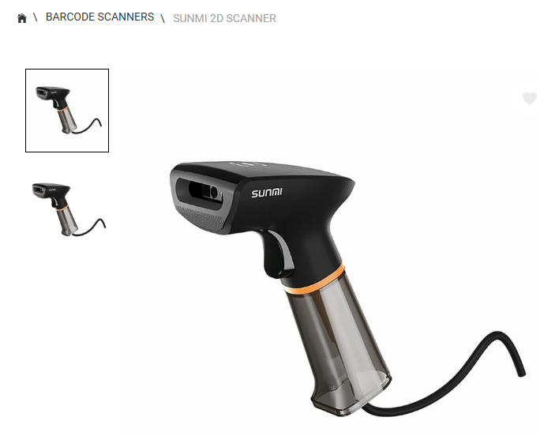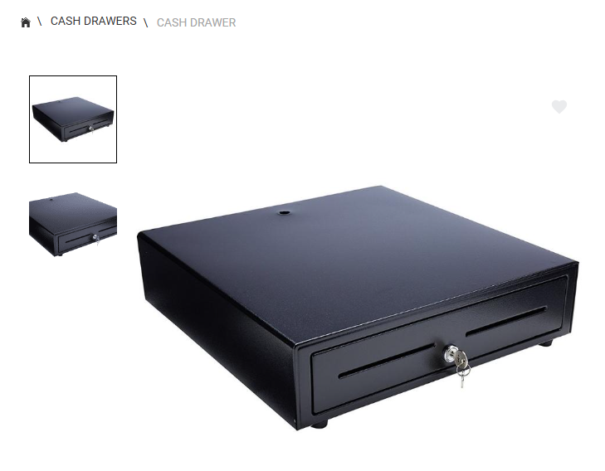

## 

**Software as a Server (Saas) Vendor list for UrbanVibe**

HRMS – INFO Tech : https://www.info-tech.com.my/hrms-software

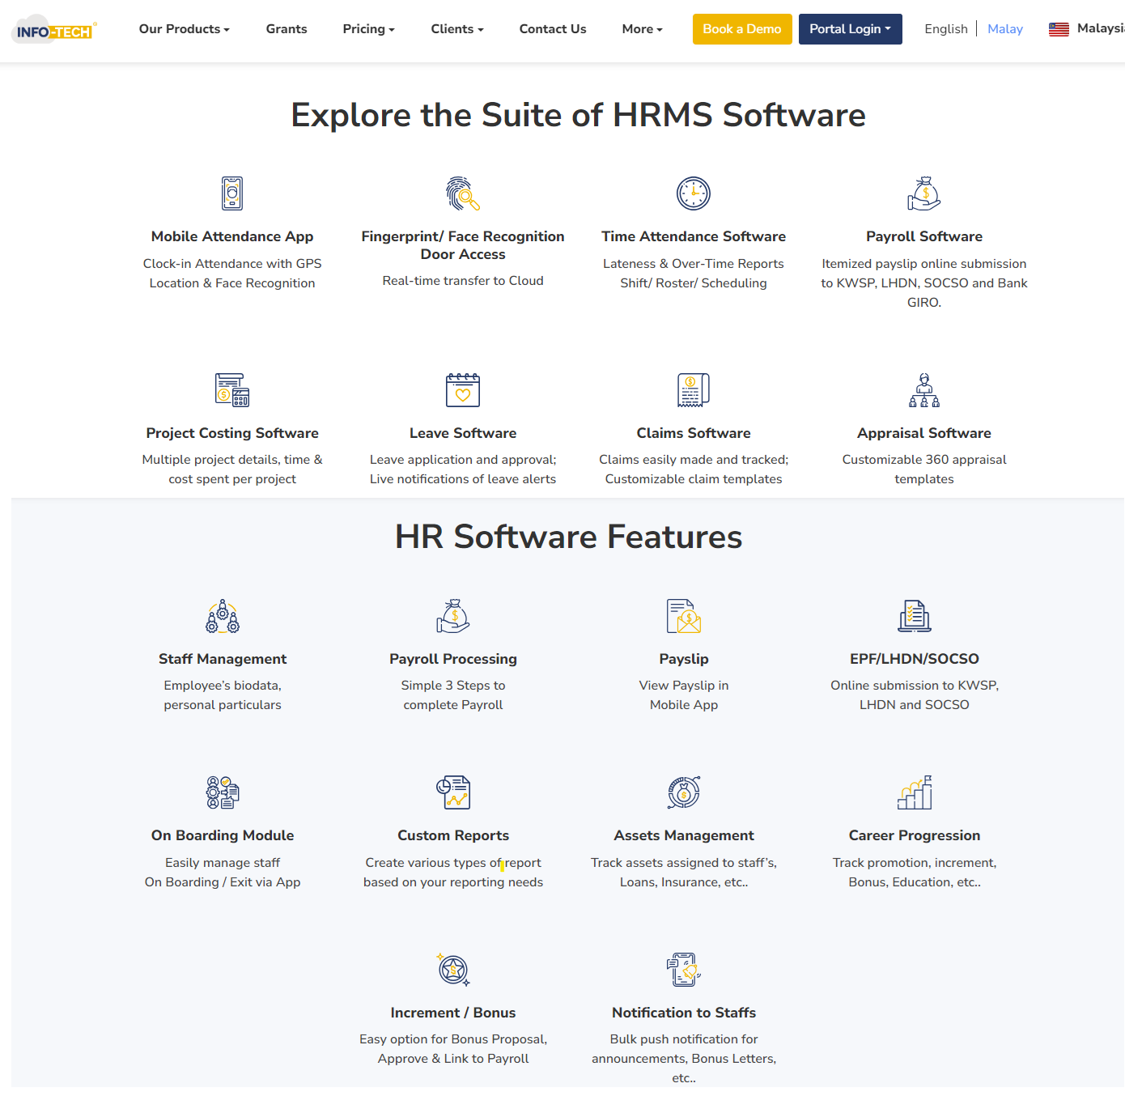

Accounting – Intuit QuickBook Online : https://quickbooks.intuit.com/my/accountants-software/features/

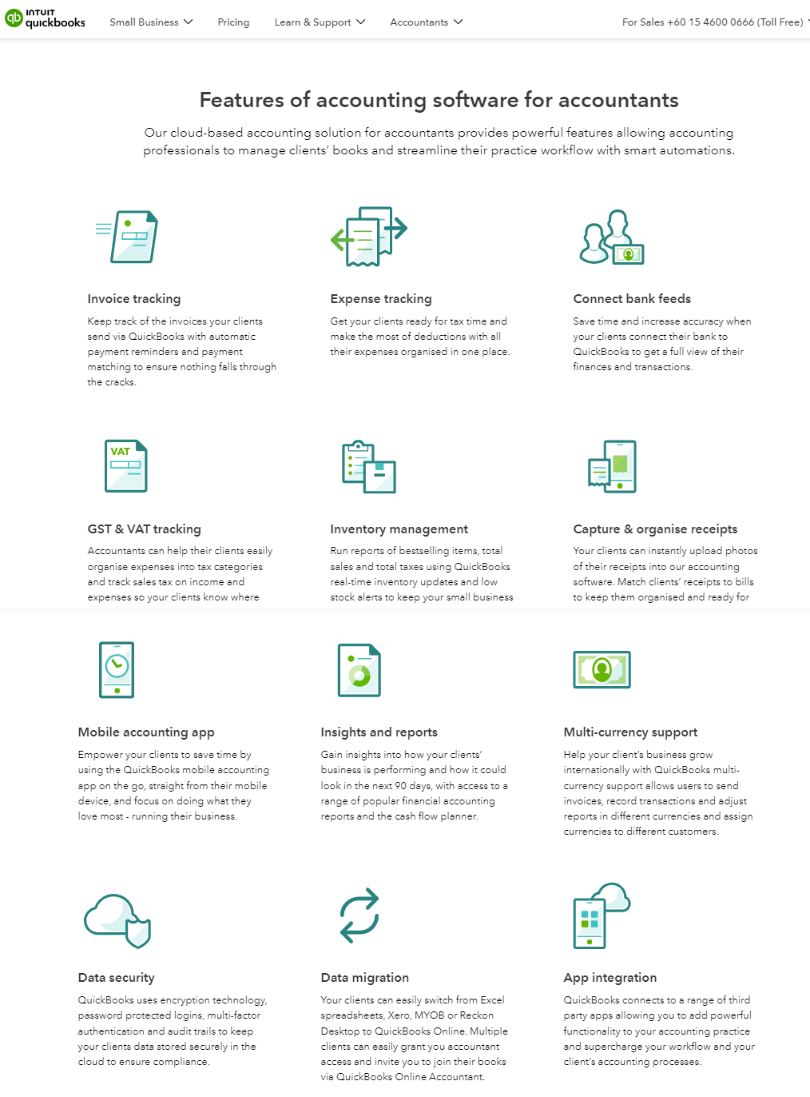

**UrbanVibe IT requirement Survey Questionnaire**

UrbanVibe IT Requirements Survey_Detail - HQ

UrbanVibe IT Requirements Survey_Detail – Outlet



UrbanVibe IT Requirements Survey - HQ(Responses)



UrbanVibe IT Requirements Survey - Outlet (Responses)



Online supporting material

Presentation video - <https://youtu.be/LPsiTaaOUsg>

Online Repositories - https://github.com/Weng1891/TSN309-TMA3.git